**A**

### **Project Report**

### **On**

### **VehiCare**

**Submitted by**

### **Soham Milind Kulkarni**

**Roll No.: 23334**

**MCA–I**

**SEM–II**

**Under the guidance of**

### **Prof. Deepali Patil**

**For the Academic Year 2023-24**



***Sinhgad Technical Education Society’s***

**Sinhgad Institute of Management**

**Vadgaon Bk Pune 411041**

**(Affiliated to SPPU Pune & Approved by AICTE New Delhi)**

### 

### Date:

**CERTIFICATE**

This is to certify that Mr. Soham Milind Kulkarni has successfully completed his project work entitled **“VehiCare”** in partial fulfillment of MCA – I SEM –II Mini Project for the year 2023-2024. He has worked under our guidance and direction.

### Prof. Deepali Patil Dr. Chandrani Singh

**Project Guide Director, SIOM-MCA**

### Examiner 1 Examiner 2

**Date:**

**Place:** Pune

**DECLARATION**

I certify that the work contained in this report is original and has been done by me under the guidance of my guide.

* The work has not been submitted to any other Institute for any degree or diploma.
* I have followed the guidelines provided by the Institute in preparing the report.
* I have conformed to the norms and guidelines given in the Ethical Code of Conduct of the Institute.
* Whenever I have used materials (data, theoretical analysis, figures, and text) from other sources, I have given due credit to them by citing them in the text of the report and giving their details in the references.

### **Name and Signature of Project Team Members**:

|  |  |  |  |
| --- | --- | --- | --- |
| **Sr. No.** | **Seat No.** | **Name of students** | **Signature of students** |
| **1** |  | **Soham Milind Kulkarni** |  |

**ACKNOWLEDGEMENT**

It is very difficult task to acknowledge all those who have been of tremendous help in this project. I would like to thank my respected guide **Prof. Deepali Patil** for providing me necessary facilities to complete my project and for their guidance and encouragement in completing my project successfully without which it wouldn’t be possible. I wish to convey my special thanks and immeasurable feelings of gratitude towards **Dr. Chandrani Singh, Director, SIOM-MCA.** I wish to convey my special thanks to all teaching and non-teaching staff members of **Sinhgad Institute of Management, Pune** for their support.

Thank You

Yours Sincerely,

Soham Milind Kulkarni

# INDEX

|  |  |  |
| --- | --- | --- |
| **Sr. No.** | **Chapter** | **Page No.** |
| 1 | **CHAPTER 1: INTRODUCTION** | 6-9 |
| 1.1 | Abstract | 6 |
| 1.2 | Existing System and Need for System | 6 |
| 1.3 | Scope of System | 7 |
| 1.4 | Operating Environment Hardware and Software | 8 |
| 1.5 | Brief Description of Technology Used | 8 |
| 2 | **CHAPTER 2: PROPOSED SYSTEM** | 10-11 |
| 2.1 | Feasibility Study | 10 |
| 2.2 | Objectives of the proposed system | 10 |
| 2.3 | Users of the system | 11 |
| 3 | **CHAPTER 3: ANALYSIS AND DESIGN** | 12-33 |
| 3.1 | Entity Relationship Diagram (ERD) | 12 |
| 3.2 | Class Diagram | 13 |
| 3.3 | Use Case Diagrams | 14 |
| 3.4 | Activity Diagram | 17 |
| 3.5 | Sequence Diagram | 20 |
| 3.6 | Component Diagram | 21 |
| 3.7 | Module and Hierarchy Diagram | 22 |
| 3.8 | Table Design | 23 |
| 3.9 | Data Dictionary | 27 |
| 3.10 | Sample Input and Output Screens  (Screens must have valid data. All reports must have at-least 5 valid records.) | 29 |
| 4 | **CHAPTER 4: CODING Sample code** | 34 |
| 5 | **CHAPTER 5: LIMITATIONS OF SYSTEM** | 37 |
| 6 | **CHAPTER 6: PROPOSED ENHANCEMENTS** | 38 |
| 7 | **CHAPTER 7: CONCLUSION** | 39 |
| 8 | **CHAPTER 8: BIBLIOGRAPHY** | 40 |

Chapter 1

**Introduction**

**1.1 Abstract**

VehiCare is a smart solution designed to make managing vehicle servicing easy and efficient. If you've ever felt frustrated with the paperwork and delays at a service centre, this system is the remedy.

VehiCare is an online system designed to streamline the maintenance process for vehicle owners and service providers. Through a user-friendly interface, users can schedule service appointments, track vehicle service history, and communicate with service centres. Mechanics can easily manage their tasks, update vehicle status, and manage their own profile. Administrator can efficiently manage appointments, track service requests, and maintain customer, mechanic records. The system enhances transparency and convenience by enabling providing real-time updates on service progress and offering invoices. VehiCare aims to optimize the vehicle maintenance experience, ensuring vehicles operate smoothly and safely while saving time and resources for both users and service providers.

This system deals with the needs of customers, mechanics, and administrators by providing an efficient platform for managing service requests, assigning tasks to mechanics, and maintaining customer and mechanic profiles. It's an all-in-one platform that simplifies how customers request service, how mechanics handle tasks, and how administrators keep everything running smoothly.

**1.2 Existing System and Need for System**

Existing System:

* Manual Record Keeping: Vehicle owners typically rely on manual methods like paper-based service logs or spreadsheets to track maintenance schedules, service history, and expenses. This process is labor-intensive and prone to errors, leading to incomplete or inaccurate records.
* Inefficient Communication: Coordinating service appointments often involves phone calls or in-person visits to service centers. This can lead to miscommunication, missed appointments, and delays in scheduling, resulting in frustration for both vehicle owners and service providers.
* Limited Transparency: Without a centralized system for managing service appointments and records, vehicle owners may lack visibility into the status of their vehicles during service, leading to uncertainty and anxiety about the progress of repairs or maintenance.
* Lack of Data Analysis: Traditional methods offer limited opportunities for service centers to analyze data on customer preferences, service trends, or performance metrics. This hampers their ability to identify areas for improvement and deliver personalized services to customers.
* Manual Invoice: Creating handwritten invoices is a time-consuming process, especially during peak hours. Handwritten invoices are susceptible to errors such as calculation mistakes, illegible handwriting, or missing information, leading to billing discrepancies and customer dissatisfaction.

Need For VehiCare:

* Streamlined Appointment Management: VehiCare eliminates the need for phone calls and in-person visits by providing an online platform where vehicle owners can easily schedule service appointments at their convenience.
* Efficient Service Tracking: By digitizing service records, VehiCare ensures that both vehicle owners and mechanics have access to accurate information about upcoming appointments, service history, and current service status.
* Enhanced Communication: The platform facilitates seamless communication between vehicle owners and mechanics, allowing for instant messaging, service updates, and feedback exchange, leading to improved customer satisfaction and service quality.
* Data-driven Insights: By capturing and analyzing service data, VehiCare enables service providers to gain valuable insights into customer preferences, service trends, and performance metrics, helping them optimize operations and improve customer retention.
* Automated Invoice: When a mechanic marks a service task as completed within the VehiCare promotes the generation of an invoice. The invoice includes all relevant details of the service performed, such as labor charges, parts used, service fees, taxes, and any additional charges.

**1.3 Scope of System:**

The scope of VehiCare is to provide a comprehensive online solution that streamlines operations, enhances communication, and delivers a transparent and user-friendly experience for customers, mechanics, and administrators alike.

Here's an expanded overview of the scope of VehiCare:

* Customer Registration: Allow users to register as customers, providing necessary information such as name, contact details, and vehicle information.
* Service Request Submission: Enable registered customers to submit service requests, specifying the type of service required and any additional details.
* Mechanic Application and Approval: Mechanics can apply to become service providers through the platform. Administrators review and approve mechanic applications based on predefined criteria.
* Request Approval and Assignment: Administrators review service requests submitted by customers, approve them, and assign them to available mechanics based on factors like location, expertise, and workload.
* Real-time Status Tracking: Provide real-time updates to customers on the status of their service requests, including when the request is received, approved, assigned to a mechanic, and completed.
* Feedback Mechanisms: Allow customers to provide feedback on their service experiences, including ratings and reviews for mechanics and overall service quality.
* Communication Channels: Facilitate communication between customers, mechanics, and administrators through integrated messaging systems, enabling them to clarify service details, provide updates, and address any issues that arise during the service process.
* User-Friendly Interface: Design a user-friendly interface for both customers and mechanics, making it easy to navigate, submit requests, track statuses, and provide feedback.
* Streamlined Service Operations: Implement workflows and automation features to streamline service operations, reduce manual effort, and improve efficiency in handling service requests and assignments.
* Enhanced Transparency: Ensure transparency throughout the service process by providing clear communication, real-time updates, and access to service history and feedback for both customers and mechanics.
* Security and Privacy: Implement robust security measures to protect user data and ensure privacy, including secure authentication, data encryption, and compliance with data protection regulations.
* Scalability: Design VehiCare to be scalable, allowing for future expansion and accommodating a growing user base and increased service demand

**1.4 Operating Environment Hardware and Software:**

**Server-side requirement**

|  |  |
| --- | --- |
| **Software Requirement** | **Hardware Requirement** |
| Operating System: Windows 7 or above | Processor: Intel Core i3 or above |
| * + 1. Front End: **HTML, CSS, JavaScript** | RAM: 4GB or above |
| Back End: **Django (Python)** | HDD: 512 GB or above |
| Database: **SQLite3** |  |
| Web Browser: Chrome Mozilla Firefox |  |

**Client-side requirement**

|  |  |
| --- | --- |
| **Software Requirement** | **Hardware Requirement** |
| Operating System: Windows 7 or above | Processor: Intel Core i3 or above |
| * + 1. Web Browser: Chrome, Mozilla Firefox | RAM: 2GB or above |
|  | HDD: 512 GB or above |

**1.5 Brief Description of Technologies Used:**

1.5.1 Frontend Technologies

• HTML, CSS, and JavaScript: Utilized for building the user interface (UI) of the VehiCare system.

1.5.2 Database

• SQLite Database: Used backend database. It offers lightweight, file-based storage, which simplifies deployment and management for smaller applications like VehiCare.

1.5.3 System Architecture

• Django Framework (Python): Employed Python, specifically the Django web framework, for developing the backend of the VehiCare system. Django provides a robust and scalable architecture for building web applications, handling tasks such as routing, data modelling, and authentication.

• Client-Server Interaction: The VehiCare system will follow a client-server architecture, where clients (vehicle owners, mechanics) interact with the server-side application built with Django. The server manages and serves data and functionalities to the clients via RESTful APIs.

1.5.4 Considerations

• Scalability: The Django framework and SQLite database can support scalability, allowing the VehiCare system to accommodate increased users or future enhancements. Django's built-in scalability features, such as caching and load balancing, can be leveraged as needed.

• Cross-Platform Compatibility: With HTML, CSS, JavaScript for the frontend and Django for the backend, the VehiCare system can achieve cross-platform compatibility, enabling it to run on various devices and web browsers without major modifications. Additionally, Django's support for RESTful APIs facilitates interoperability with different client platforms.

Chapter 2

**Proposed System**

**2.1 Feasibility Study:**

**2.1.1 Technical Feasibility:**

**The VehiCare system is technically feasible, leveraging industry-standard technologies such as Django for efficient development and SQLite3 for robust database management. Django's comprehensive framework offers powerful features for building scalable web applications, while SQLite3’s flexible document-oriented structure accommodates the dynamic data needs of the system. The chosen software stack ensures compatibility, scalability, and reliability, meeting the technical requirements of the project both now and in the future.**

**2.1.2 Economic Feasibility:**

**Economically, the development of the VehiCare system is justified by the significant benefits it offers. Anticipated improvements in efficiency, reduction of manual errors, and enhanced customer satisfaction outweigh the initial investment in hardware and software. The projected cost savings from streamlined processes and increased revenue from satisfied customers contribute to a favourable cost-benefit ratio.**

**2.1.3 Operational Feasibility:**

**Operationally, the VehiCare system boasts high feasibility, simplifying processes for all stakeholders involved. Its intuitive user interface minimizes training requirements, ensuring a smooth transition from existing manual systems to the automated platform. Clear communication channels and transparent processes further enhance operational efficiency, making VehiCare a practical and valuable tool for vehicle owners, mechanics, and administrators alike.**

**2.2 Objectives of the Proposed System:**

**The proposed system is an integrated Vehicle Servicing System that automates service centre operations. It provides a user-friendly interface for customers, mechanics, and administrators to perform their tasks efficiently. The system ensures real-time communication, automated task assignments, and streamlined management of service requests.**

**Objectives of the Proposed System:**

**1. User-Friendly Interface:**

**The system offers an intuitive and easy-to-navigate interface for customers, mechanics, and administrators.**

**Streamlined processes ensure that users can quickly perform tasks without unnecessary complexity.**

**2. Automated Service Request Processing:**

**Customers can submit service requests, including vehicle details and problem descriptions.**

**The system automates the approval process, ensuring swift responses from administrators.**

**3. Real-Time Task Assignment:**

**Mechanics receive information for assigned tasks.**

**Administrators can efficiently assign tasks to mechanics based on their skills and availability.**

**4. Transparent Status Tracking:**

**Customers can track the status of their service requests in real-time.**

**Mechanics can update the status of a service request, providing transparency in the repair process.**

**5. Integrated Invoice Management:**

**Customers can view detailed invoices for the services provided.**

**Administrators have a centralized view of all service costs, facilitating financial management.**

**6. Comprehensive User Profiles:**

**Customers and mechanics can manage their profiles, including personal information and preferences.**

**Administrators have access to user profiles for effective system administration.**

**7. Feedback Mechanism:**

**Both customers and mechanics can provide feedback to administrators, fostering continuous improvement.**

**Administrators can review and respond to feedback for enhanced service quality.**

**8. Efficient Mechanic Salary Tracking:**

**Mechanics can easily track their salary information and performance.**

**Administrators have a clear overview of mechanic salaries and performance statistics.**

**2.3 Users of the System:**

VehiCare presents a comprehensive vehicle service management solution for the needs of vehicle owners, mechanics, and administrators.

For vehicle owners, VehiCare offers a user-friendly platform to effortlessly schedule service appointments, track maintenance history, and communicate with mechanics in real-time. With VehiCare, vehicle owners enjoy unparalleled convenience and peace of mind, knowing that their vehicle is in capable hands.

For mechanics, VehiCare provides a seamless workflow for managing service requests, updating service statuses, and maintaining clear communication with customers. With VehiCare, mechanics can optimize their schedules, deliver exceptional service, manage salary options and foster lasting customer relationships.

For administrators, VehiCare offers powerful tools for overseeing the entire service operation. Administrators can manage user accounts, approve service requests, approve mechanics, track their attendance, and monitor system performance in real-time. VehiCare equips administrators with the insights and capabilities needed to ensure smooth operations and deliver a superior service experience.

Chapter 3

**Analysis and Design**

**3.1 Entity Relationship Diagram (ERD):**

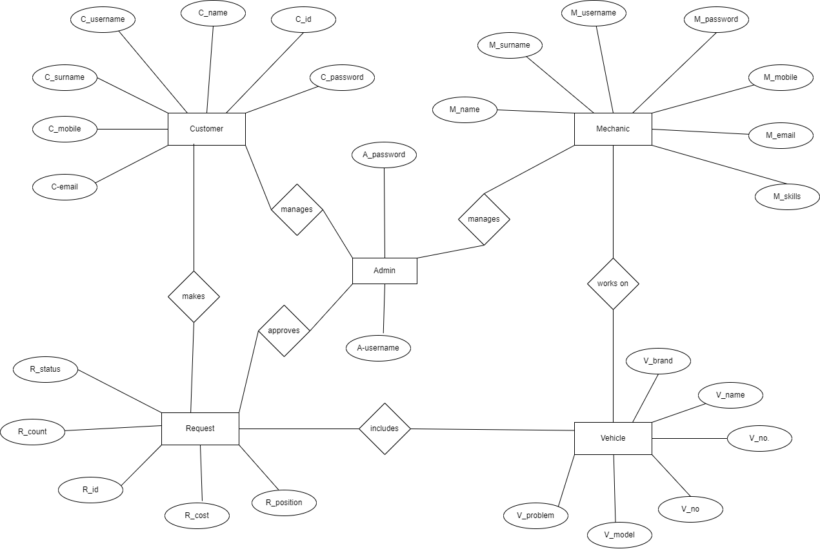

**3.2 Class Diagram:**

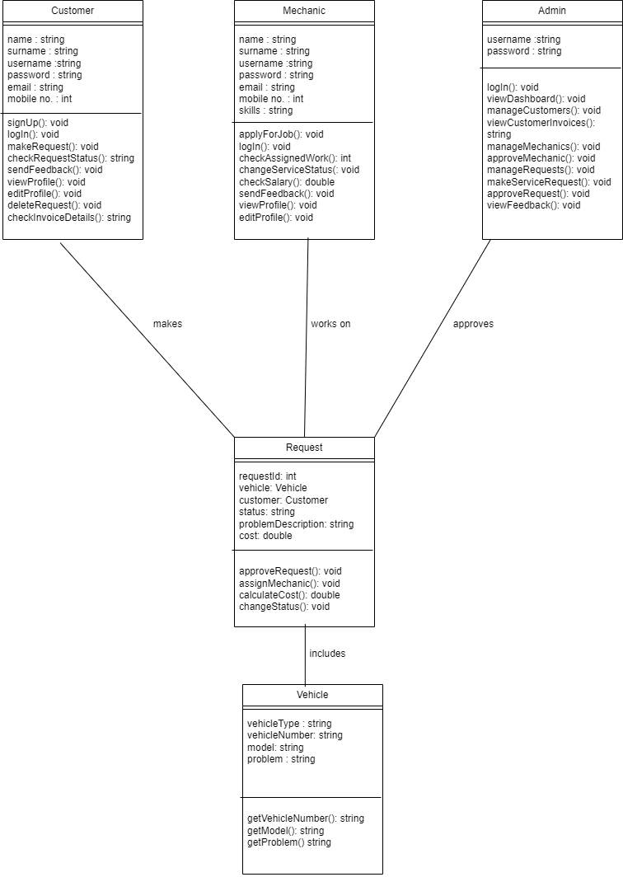

**3.3 Use Case Diagram (Customer):**

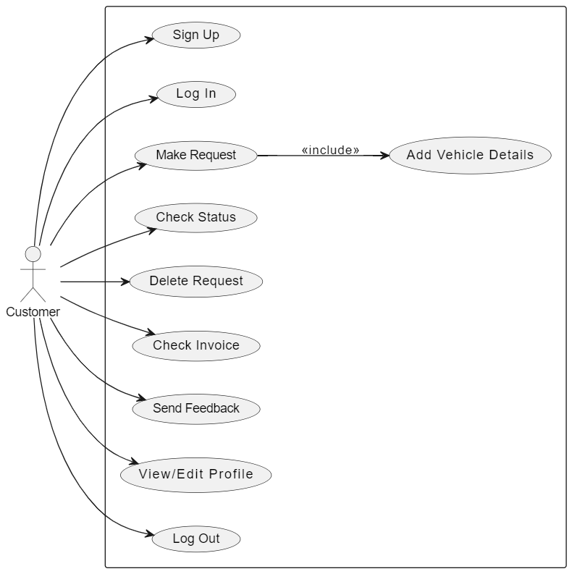

**Use Case Diagram (Mechanic):**

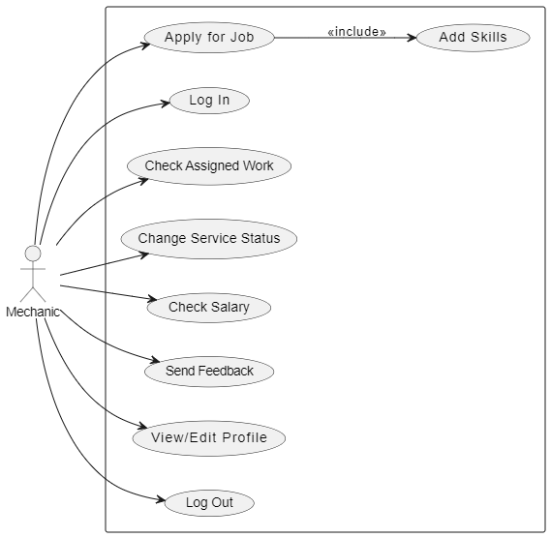

**Use Case Diagram (Admin):**

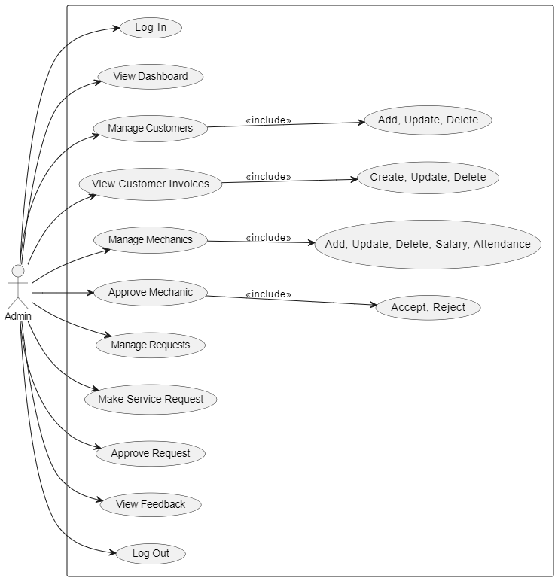

**3.4 Activity Diagram (Customer):**

**Activity Diagram (Mechanic):**

**Activity Diagram (Admin):**

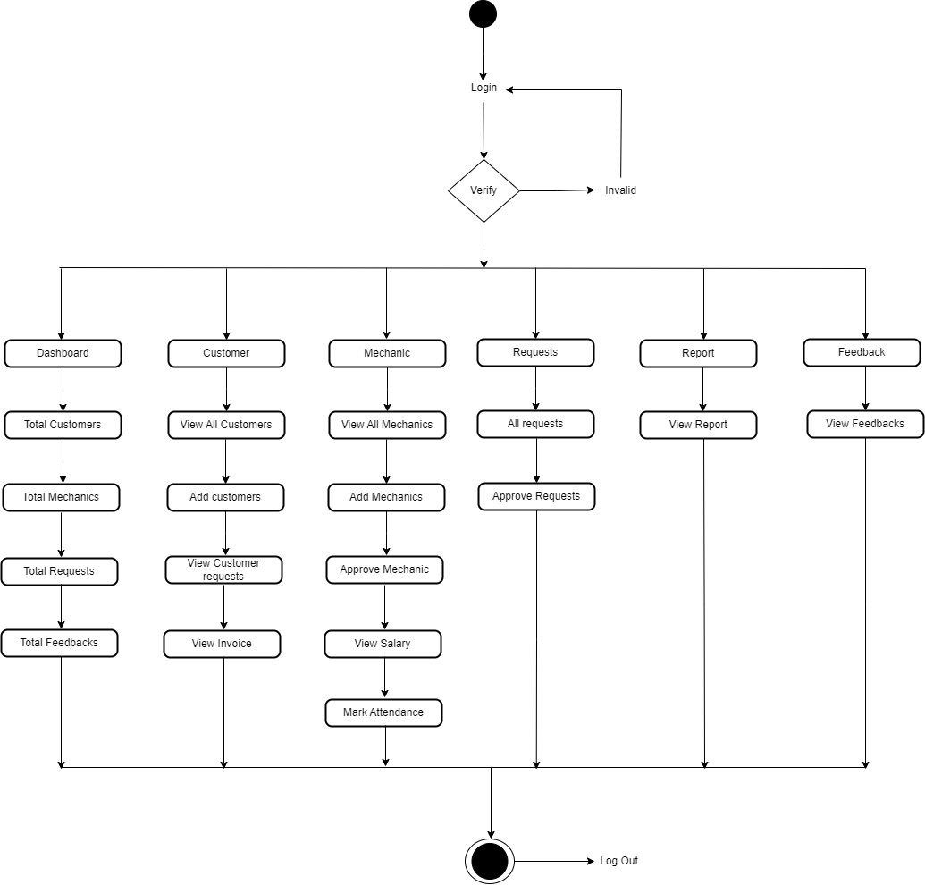

**3.5 Sequence Diagram:**

**3.6 Component Diagram:**

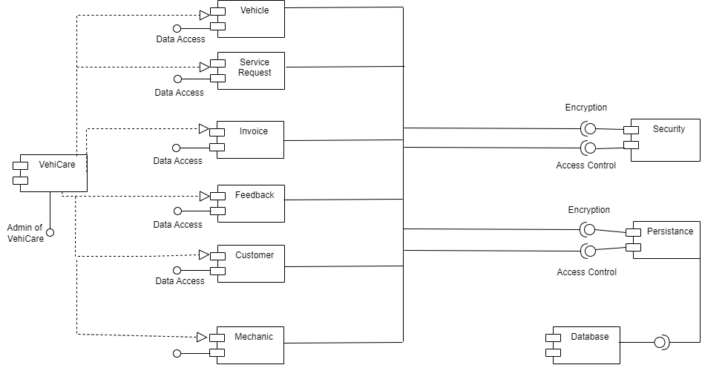

**3.7 Module and Hierarchical Diagram:**

**3.8 Table Design:**

TABLE NAME – customers

TABLE DESCRIPTION – Contains all the necessary information about Customer.

|  |  |  |  |  |  |
| --- | --- | --- | --- | --- | --- |
| **Sr No.** | **Name** | **Type** | **Size** | **Constraints** | **Description** |
| 1 | name | string | 20 | Not Null | Customer Name |
| 2 | surname | string | 20 | Not Null | Customer surname |
| 3 | username | string | 20 | Not Null  Unique | Customer username |
| 4 | password | string | 20 | Not Null  Unique | Customer password |
| 5 | Mobile no. | int | 10 | Not Null | Customer Mobile Number |
| 6 | Email Id | string | 20 | Not Null  Unique | Customer Email Id |
| 7 | Address | text | 50 | Not Null | Customer Address |
| 8 | Profile Photo | Image Field | 50 | Not Null | Customer Profile Photo |

TABLE NAME – Mechanic

TABLE DESCRIPTION – Contains all the necessary information about Mechanic.

|  |  |  |  |  |  |
| --- | --- | --- | --- | --- | --- |
| **Sr No.** | **Name** | **Type** | **Size** | **Constraints** | **Description** |
| 1 | name | string | 20 | Not Null | Mechanic Name |
| 2 | surname | string | 20 | Not Null | Mechanic  surname |
| 3 | username | string | 20 | Not Null  Unique | Mechanic username |
| 4 | password | string | 20 | Not Null  Unique | Mechanic password |
| 5 | Mobile no. | int | 10 | Not Null | Mechanic Mobile Number |
| 6 | Email Id | string | 20 | Not Null  Unique | Mechanic Email Id |
| 7 | Address | text | 50 | Not Null | Mechanic Address |
| 8 | Skills | text | 50 | Not Null | Mechanic  Skills |
| 9 | Profile Photo | Image Field | 50 | Not Null | Mechanic Profile Photo |

TABLE NAME – Vehicle

TABLE DESCRIPTION – Contains all the necessary information about Vehicle.

|  |  |  |  |  |  |
| --- | --- | --- | --- | --- | --- |
| **Sr No.** | **Name** | **Type** | **Size** | **Constraints** | **Description** |
| 1 | category | string | 20 | Not Null | Vehicle Category |
| 2 | number | string | 20 | Not Null | Vehicle number |
| 3 | model | string | 20 | Not Null | Vehicle  model |
| 4 | name | string | 20 | Not Null | Vehicle  name |
| 5 | brand | int | 10 | Not Null | Vehicle  brand |
| 6 | problem | string | 20 | Not Null | Problem description |

TABLE NAME – Mechanic Attendance

TABLE DESCRIPTION – Contains all the necessary information about Mechanic Attendance.

|  |  |  |  |  |  |
| --- | --- | --- | --- | --- | --- |
| **Sr No.** | **Name** | **Type** | **Size** | **Constraints** | **Description** |
| 1 | name | string | 20 | Not Null | Mechanic  name |
| 2 | date | Date Field | 20 | Not Null | Date |
| 3 | Status | string | 10 | Not Null | Present/  Absent |

TABLE NAME – Feedback

TABLE DESCRIPTION – Contains all the necessary information about Feedback from Customer and Mechanic.

|  |  |  |  |  |  |
| --- | --- | --- | --- | --- | --- |
| **Sr No.** | **Name** | **Type** | **Size** | **Constraints** | **Description** |
| 1 | date | Date Field | 20 | Not Null | Date of Feedback |
| 2 | name | string | 20 | Not Null | Sender of  Feedback |
| 3 | message | string | 50 | Not Null | Feedback |

**3.9 Data Dictionary:**

|  |  |  |  |  |  |
| --- | --- | --- | --- | --- | --- |
| **Sr No.** | **Name** | **Type** | **Size** | **Constraints** | **Description** |
| 1 | name | string | 20 | Not Null | Mechanic Name |
| 2 | surname | string | 20 | Not Null | Mechanic  surname |
| 3 | username | string | 20 | Not Null  Unique | Mechanic username |
| 4 | password | string | 20 | Not Null  Unique | Mechanic password |
| 5 | Mobile no. | int | 10 | Not Null | Mechanic Mobile Number |
| 6 | Email Id | string | 20 | Not Null  Unique | Mechanic Email Id |
| 7 | Address | text | 50 | Not Null | Mechanic Address |
| 8 | Skills | text | 50 | Not Null | Mechanic  Skills |
| 9 | Profile Photo | Image Field | 50 | Not Null | Mechanic Profile Photo |
| 10 | category | string | 20 | Not Null | Vehicle Category |
| 11 | number | string | 20 | Not Null | Vehicle number |
| 12 | model | string | 20 | Not Null | Vehicle  model |
| 13 | name | string | 20 | Not Null | Vehicle  name |
| 14 | brand | int | 10 | Not Null | Vehicle  brand |
| 15 | problem | string | 20 | Not Null | Problem description |
| 16 | name | string | 20 | Not Null | Mechanic  name |
| 17 | date | Date Field | 20 | Not Null | Date |
| 18 | Status | string | 10 | Not Null | Present/  Absent |
| 19 | date | Date Field | 20 | Not Null | Date of Feedback |
| 20 | name | string | 20 | Not Null | Sender of  Feedback |
| 21 | message | string | 50 | Not Null | Feedback |

**3.10 Input/Output Screens:**

Home Page:

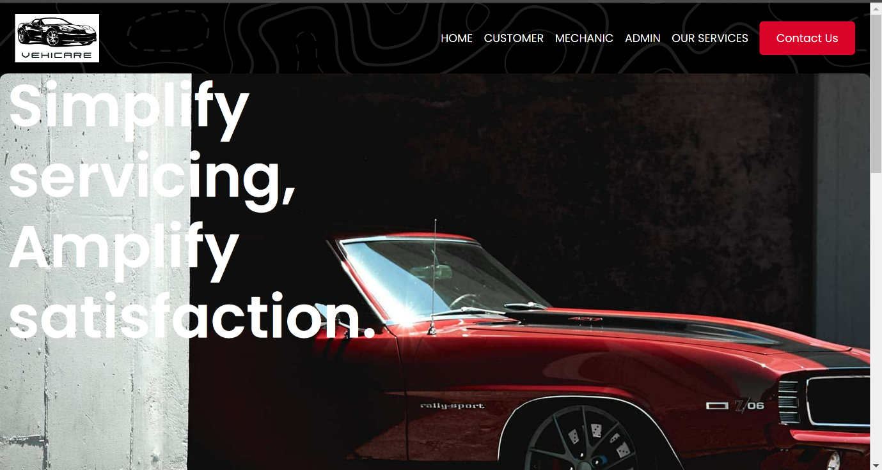

Customer Sign up:

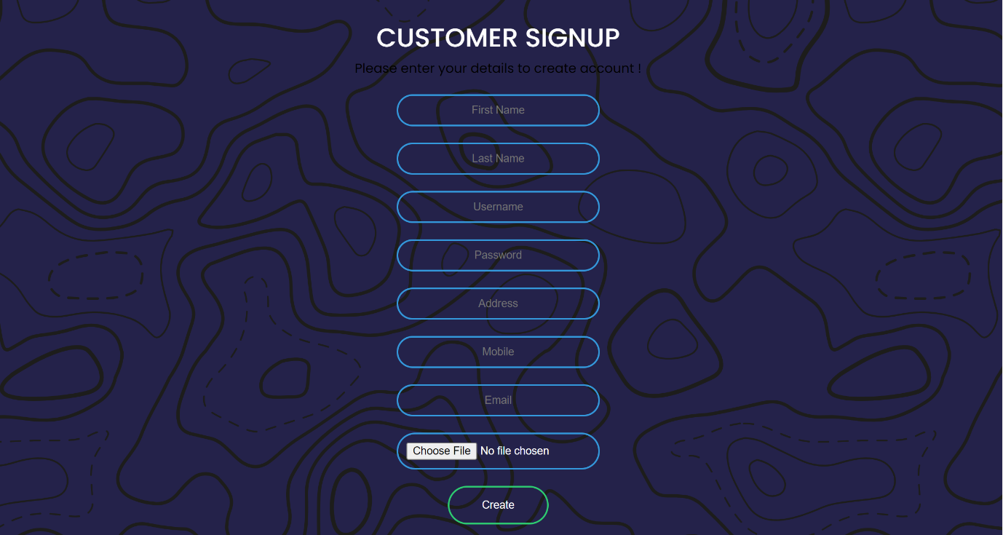

Customer Login:

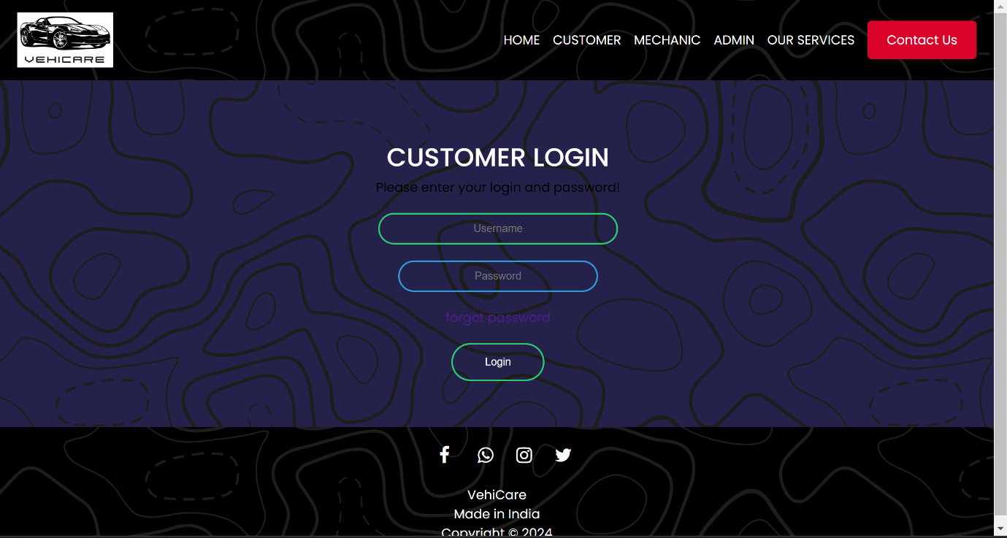

Customer Dashboard:

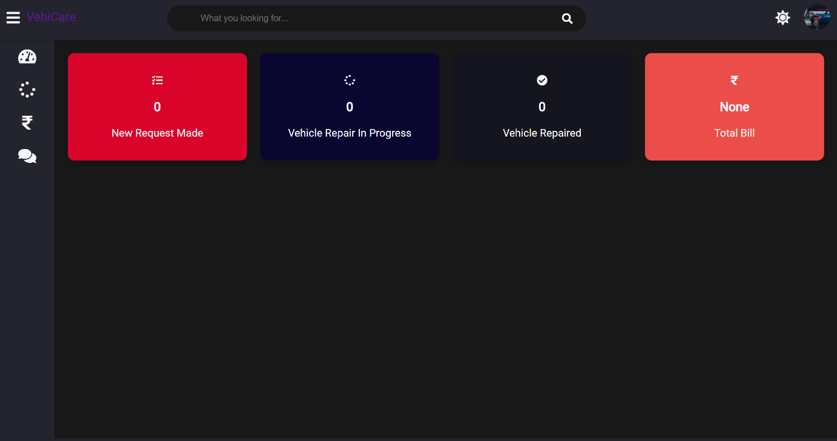

Customer Make Service Request:

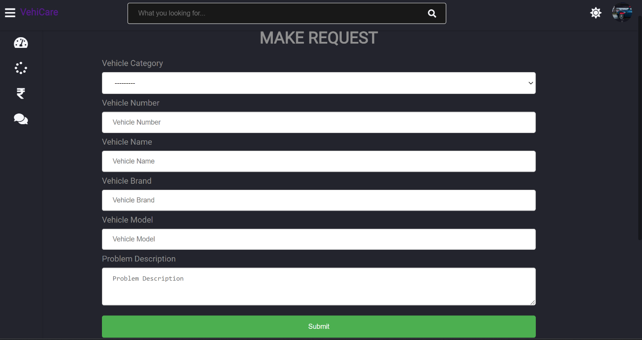

Mechanic Sign up:

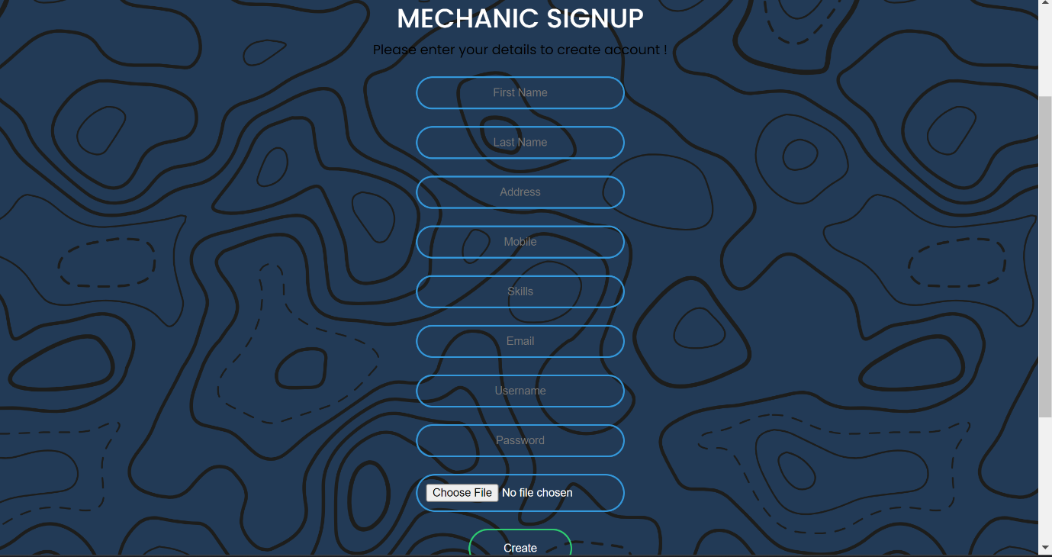

Mechanic Login:

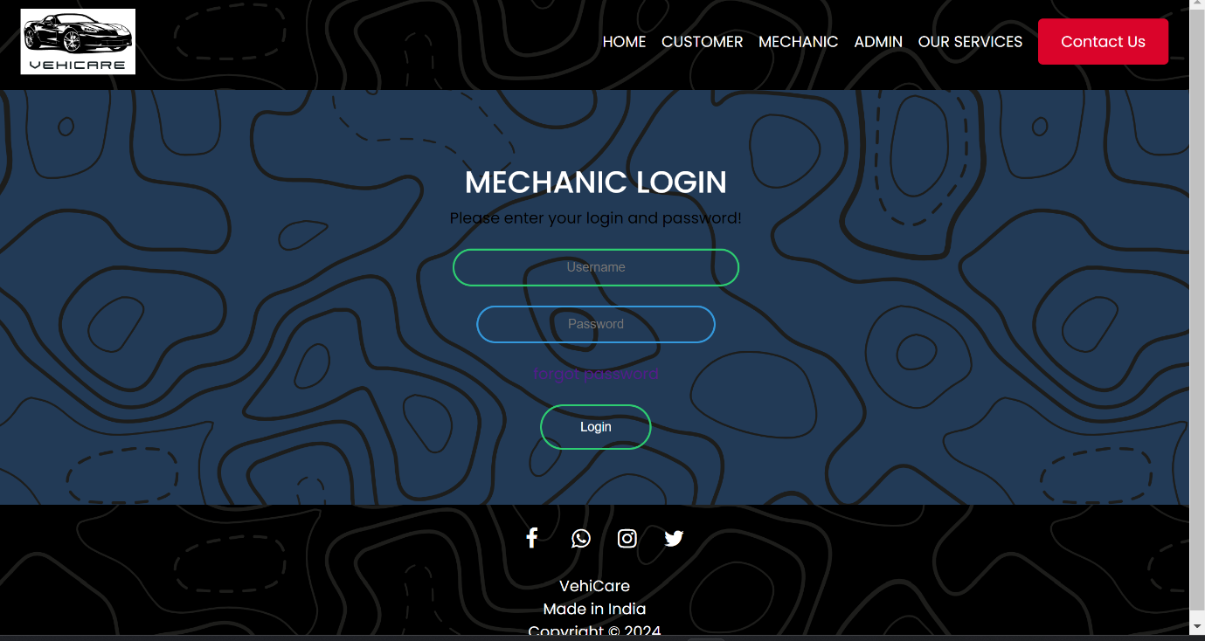

Mechanic Dashboard:

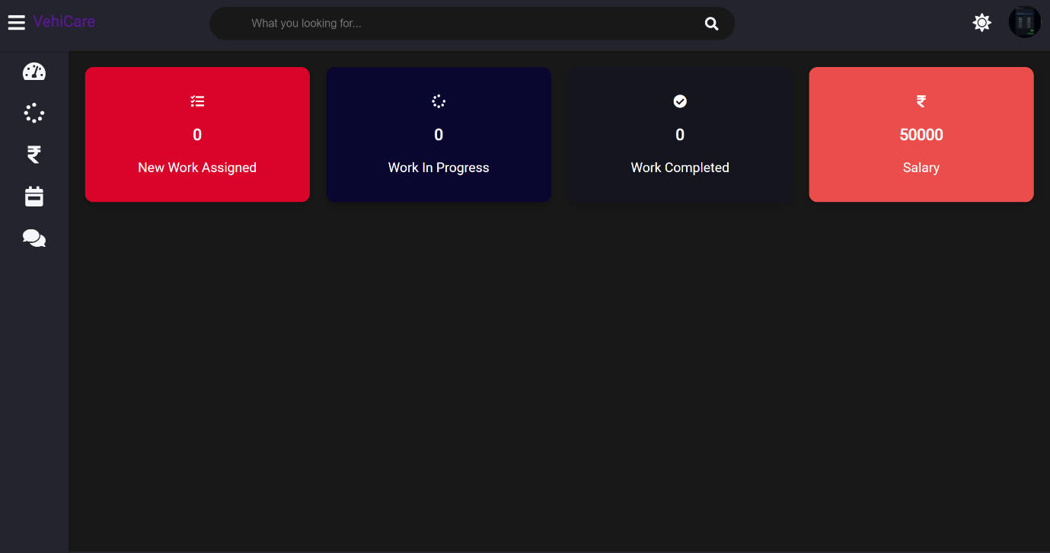

Admin Login:

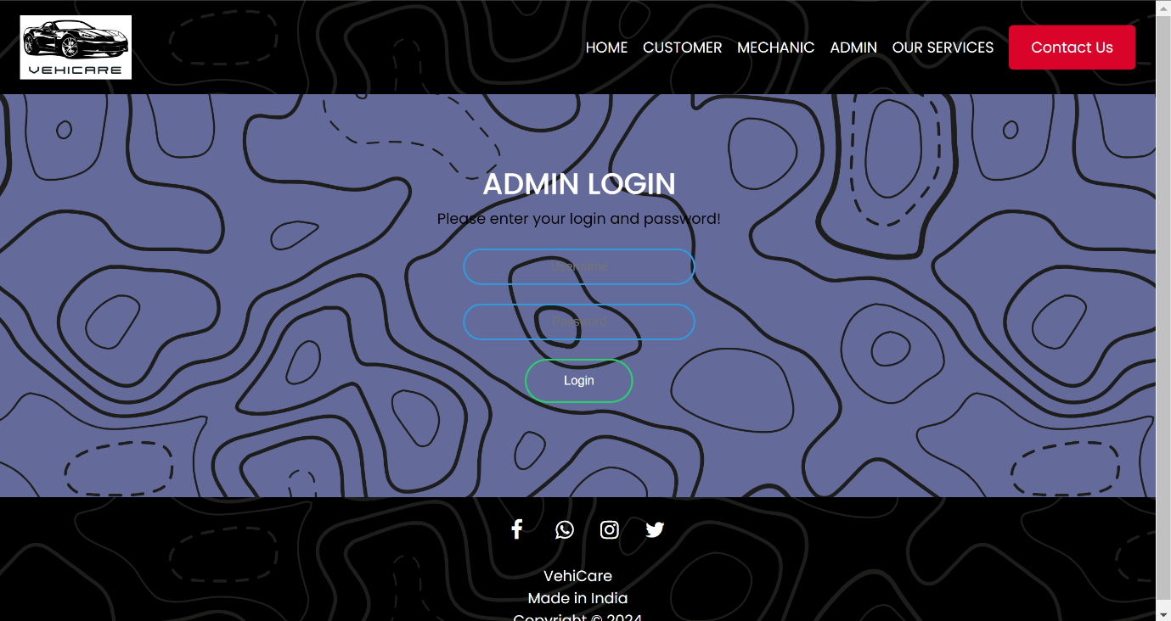

Admin Dashboard:

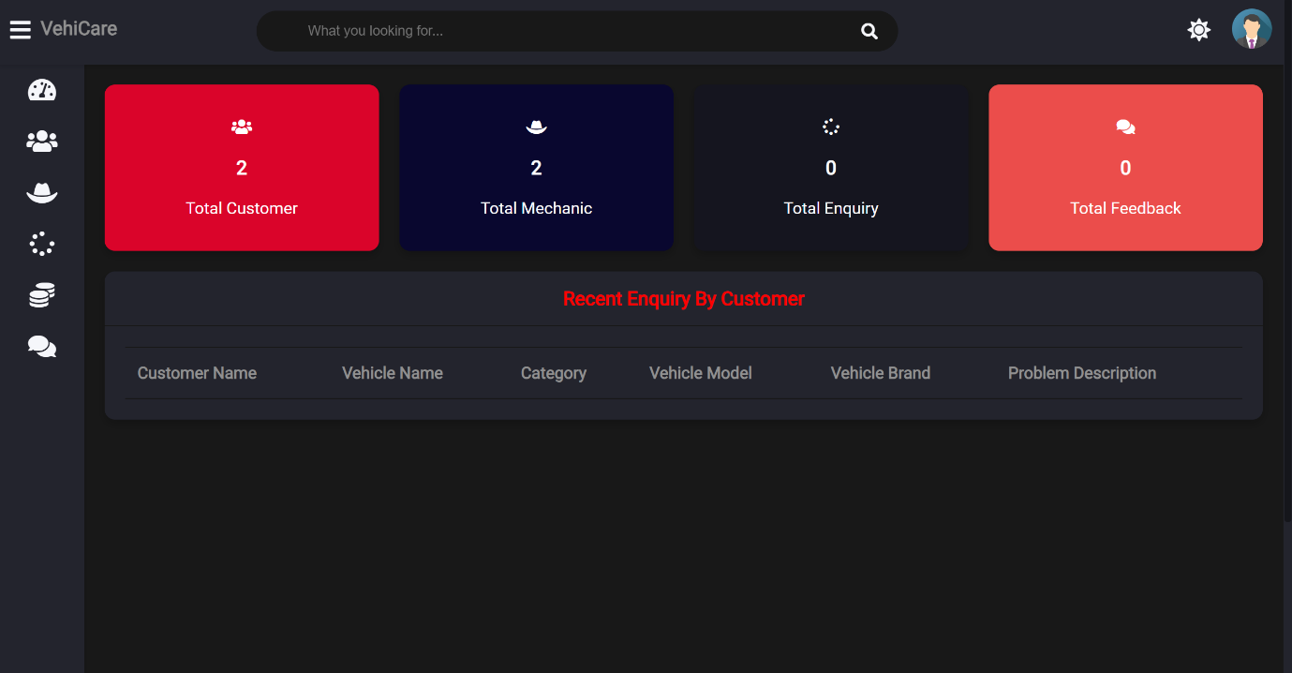

Chapter 4

**Coding (Sample Code)**

**Index.html (Home Page)**

<!DOCTYPE html>

{% load static %}

<html lang="en" dir="ltr">

<head>

<meta charset="utf-8">

<style media="screen">

body{

padding-top: 0rem;

padding-bottom: 0rem;

margin: 0px;

background: rgb(13, 13, 13) url(/static/images/image_graphics.svg) center/ 510px repeat;

}

.sector1{

background: #211f1f url('/static/images/new_bg.png');

background-size:cover;

background-repeat: no-repeat;

padding: 0%;

border-radius: 1%;

}

h1:hover{

transform: scale(1.05);

transition: 0.5s;

}

h1{

padding: 5px;

margin-left: 20px;

}

.sector2{

text-align: center;

background-color: black;

padding: 0%;

margin: 0%;

color: white;

}

.image-info-section {

display: flex;

justify-content: space-between;

align-items: center;

padding: 20px;

background: rgb(13, 13, 13) url(/static/images/image_graphics.svg) center/ 510px repeat;

}

.image-container {

flex: 1;

margin-right: 20px;

}

.image-container img {

max-width: 100%;

height: auto;

border-radius: 2%;

}

.info-container {

flex: 1;

}

.info-container h2 {

font-size: 30px;

margin-bottom: 10px;

}

.info-container h2:hover{

opacity: 0.5;

color: #da042a;

transform: scale(1.05);

transition: 0.5s;

}

.info-container p {

font-size: 20px;

line-height: 1.6;

}

</style>

</head>

<body>

{% include "vehicle/new_nav.html" %}

<div class="sector1">

<div class="header__content">

<h1>Simplify servicing, <br>Amplify satisfaction. </h1>

<div class="header__btn"></div>

</div>

<br><br><br><br><br><br><br><br><br>

<br><br><br><br><br><br><br><br><br>

</div>

<div class="sector2 pattern">

<section class="image-info-section">

<div class="image-container">

<img src="/static/images/intro1.png" alt="Image">

</div>

<div class="info-container">

<h2>VehiCare</h2>

<p>A smart solution designed to make managing vehicle servicing efficient and easy. It's an all-in-one platform that simplifies how customers request service, how mechanics handle tasks. This system deals with the needs of customers and mechanics

by providing an efficient platform for managing service requests, service tasks and maintaining the profiles. <br><br>

We offer various services. <br><br>

</p>

<a href="/services" style="color: #da042a;">Explore our Services</a>

</div>

</section>

<section class="reasons"></section>

{% include "vehicle/footer.html" %}

</body>

</html>

**views.py (home view)**

def home_view(request):

if request.user.is_authenticated:

return redirect('afterlogin')

else:

return render (request, 'vehicle/index.html')

**urls.py (home url):**

path('',views.home_view,name='home'),

Chapter 5

**Limitations of the System**

While VehiCare offers numerous benefits in streamlining vehicle service management, it also has certain limitations:

* Dependency on Internet Access:

VehiCare relies on internet connectivity for users to access its features. In areas with limited or unreliable internet access, users may experience difficulties in scheduling appointments or accessing real-time updates.

* Platform Compatibility:

While efforts are made to ensure cross-platform compatibility, certain features of VehiCare may not function optimally on all devices or web browsers. Users may encounter compatibility issues, particularly on older devices or less common browsers.

* Limited Customization:

VehiCare may have limited customization options for service centers, restricting their ability to tailor the platform to their specific needs or branding requirements. This limitation could affect the user experience and branding consistency for service centers.

* Scalability Challenges:

While VehiCare is designed to accommodate a growing user base, scalability challenges may arise as the system experiences increased usage. High traffic volumes or spikes in service requests could lead to performance issues or system downtime.

* Security Concerns:

Despite robust security measures, VehiCare may still be vulnerable to security breaches or data leaks. Users' personal information and vehicle data could be compromised, posing privacy risks and damaging trust in the platform.

* Complexity for Non-Technical Users:

VehiCare may present a learning curve for users who are not familiar with technology or online platforms. Navigating the interface and understanding how to use its features effectively could be challenging for some users, particularly older individuals or those with limited digital literacy.

* Geographical Limitations:

VehiCare's availability and functionality may be limited to certain geographical regions or markets. Users in areas with limited coverage or infrastructure may not be able to fully utilize the platform's features or may have access to fewer service providers, limiting their options for vehicle maintenance.

* Integration Challenges:

Integrating VehiCare with existing systems or workflows at service centres may pose challenges. Compatibility issues with legacy systems or the need for additional training and support for staff could hinder the seamless adoption of VehiCare into existing business processes.

* Data Accuracy and Reliability:

While VehiCare aims to provide accurate and reliable information, there may be instances of data discrepancies or inaccuracies. Errors in service records, appointment scheduling, or vehicle information could lead to confusion and dissatisfaction among users.

Chapter 6

**Proposed Enhancements**

Following are some of the proposed enhancements for the VehiCare:

* Mobile Application:

Develop a mobile application for VehiCare to provide users with greater convenience and accessibility. The app can offer all the features available on the web platform, optimized for mobile devices, allowing users to schedule appointments, track service status, and communicate with mechanics on the go.

* Predictive Maintenance Alerts:

Implement predictive maintenance alerts based on vehicle usage and manufacturer recommendations. VehiCare can analyze vehicle data to predict when maintenance tasks such as oil changes, tire rotations, or brake inspections are due, sending automated reminders to users to schedule appointments.

* Integration with Vehicle Diagnostics:

Integrate VehiCare with vehicle diagnostics systems to provide mechanics with real-time insights into vehicle health and performance. This integration can enable proactive maintenance and faster diagnosis of issues, improving service quality and reducing downtime for vehicle owners.

* Enhanced Communication Features:

Expand communication features within VehiCare to include multimedia messaging, voice calls, and video conferencing options. This allows for more effective communication between users and mechanics, facilitating clearer explanations of service needs and reducing misunderstandings.

* Customer Loyalty Program:

Introduce a customer loyalty program within VehiCare to reward frequent users and encourage repeat business. Users can earn points or discounts for every service appointment booked through the platform, incentivizing loyalty, and fostering long-term relationships with service providers.

* Integration with Parts Suppliers:

Partner with parts suppliers to integrate VehiCare with their inventory systems. This allows mechanics to easily source and order parts directly through the platform, reducing turnaround time for repairs and ensuring timely completion of service tasks.

* Data Analytics Dashboard:

Develop a comprehensive data analytics dashboard for administrators and service providers to gain insights into service trends, customer behavior, and operational performance. This dashboard can help identify areas for improvement, optimize resource allocation, and make data-driven decisions to enhance overall service quality.

* Expand Service Offerings:

Expand VehiCare's service offerings to include additional vehicle-related services such as detailing, windshield replacement, or roadside assistance. This diversification attracts a broader range of users and positions VehiCare as a comprehensive solution for all vehicle service needs.

Chapter 7

**Conclusion**

In conclusion, VehiCare stands as a solution in the world of vehicle servicing, offering a user-centric platform that revolutionizes the way vehicle owners and mechanics interact. Through its intuitive interface, streamlined processes, and innovative features, VehiCare addresses the inherent challenges of traditional service management systems, ensuring efficiency, transparency, and satisfaction.

VehiCare is a valuable tool that simplifies the way mechanics manage their workload and communicate with customers. With features like streamlined appointment management and real-time updates, VehiCare helps mechanics stay organized and deliver excellent service. Plus, with the platform's proposed enhancements, mechanics can look forward to even greater efficiency and satisfaction in their work.

VehiCare offers administrators powerful tools to oversee and optimize the entire vehicle service operation. From managing user accounts to monitoring system performance, VehiCare empowers administrators to ensure smooth operations and deliver a superior service experience. With ongoing enhancements and a commitment to excellence, VehiCare remains at the forefront of vehicle service management technology.

Overall, VehiCare is changing the way we take care of our vehicles. It's making things simpler and better for everyone involved. With VehiCare, taking care of your vehicle is a breeze.

Chapter 8

**Bibliography**

Reference Book:

Django For Beginners

Websites:

1.www.youtube.com

2.www.djangoproject.com

3.www.sqlite.org

4.127.0.0.8000